# **RAD REPORT:**

# INTRODUCTION:

## PURPOSE OF THE SYSTEM:

The purpose of Blood Banks Management System is to manage and centralize all the data of all the blood banks and provide user with facilities to search the nearest blood banks in any case of emergency or if the user is new to the city or country and don’t know where to go.

## SCOPE OF THE SYSTEM:

The scope of our project for the time being is limited to only 10 blood banks and although admin can add new blood banks but in future we can widen the scope to manage data of all the blood banks in the country.

## OBJECTIVE AND SUCCESS CRITERIA:

Objective of the system is to save time of the user to search for blood banks and search for blood availability in the nearest blood bank. Once we can manage the data of all the blood banks and search blood banks through MAP APIs we can sell it in the market.

# PROPOSED SYSTEM:

## FUNCTIONAL REQUIREMENTS:

The functional requirements of the system is divided into two parts. Admin and user.

## ADMIN:

* Admin can **sign in** and **sign up**
* Admin can **see** all the blood banks data
* Admin can **Add** Blood banks
* Admin can **see** all the donors
* Admin can **Accept** or **Delete** request for blood bottles
* Admin can **Manage** blood requests
* Admin can **Delete** blood bank data
* Admin can **Search** for specific blood bank
* Admin can **Search** for specific donor

## USER:

* User can **Request** for blood bottles
* User can **Search** for the nearest blood bank
* User can **Fill out** the form to make request
* User can directly **Become a donor**
* User can **See** all the basic info of all blood banks
* User can **Select** specific blood bank

**DATA OF THE USER THAT WILL BE USED IN FORM AND DATABASE:**

* Name
* NIC
* Phone Number
* Address
* Blood type
* No. of bottles
* Gender
* Age

**DATA OF BLOOD BANK THAT WILL BE USED IN BLOOD BANK DATABASE:**

* Name of blood bank
* Address
* Postal code
* No of bottles

## NON FUNCTIONAL REQUIREMENTS:

* System UI should be red in color
* Buttons should be placed in center of the form
* UI should be easily understandable
* Every form should pop up in the center of the screen
* Button color should be gray

# **UML DIAGRAMS:**

## USE CASE DIAGRAM:

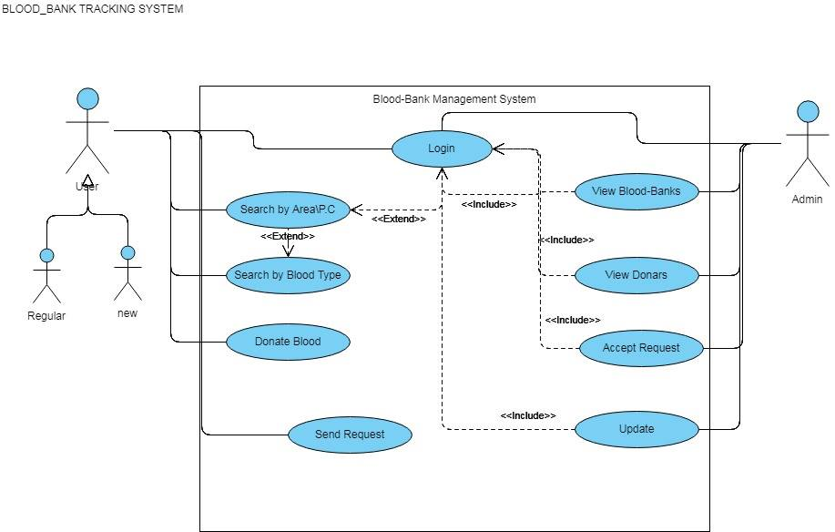

## CLASS DIAGRAM:

